Country Safety Index

**Theoretical Framework**

The purpose of this index is to develop a metric that reflects the safety of countries worldwide by looking at crime, law enforcement and environmental risks.

**Features**

* 2023 GDP
* Corruption 2022
* Burgalary 2022
* Theft 2022
* Intentional Homocide
* kidnappings
* assault
* sexual violence
* Police per country
* traffic fatalities
* natural disaster
* youth unemployment
* gun ownership
* military per country

I got my data from various sources, but mainly from World Bank.

**Data Cleaning**

A big issue I noted was duplicate countries due to different naming conventions in the different csv files. Because there was too much data for me to handle manually, I got AI to generate the standardization mapping automatically, using a dictionary of common name variants and their corresponding standardized country names.  This helped remove duplicates caused by naming differences and made the data more consistent across all sources.

In my data I had rows that were not countries e.g Region of Africa. I got a list of countries online in json format and used it to filter out and remove any row that was not in that list.

**Filling In Missing Data**

I replaced missing data with the mean in their column.

**Dealing With Outliers**

To deal with outliers I first displayed a boxplot for each of my features this allowed me to see the extreme values of each data. After that I created a function that replaced outliers and displayed the boxplots again.

**Multivariate Analysis**

To see the correlations between my features I created a heatmap. Because no features were super strongly correlated I did not have to drop any features.

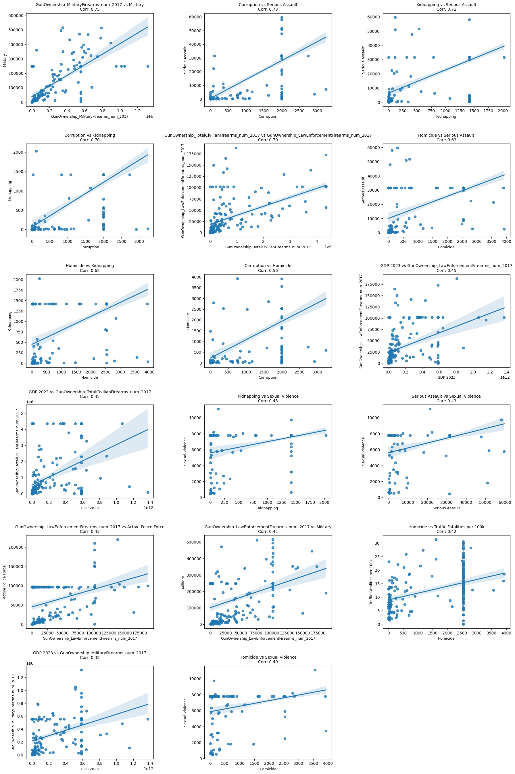

**PCA and Clustering Visuals**

Because each point had text in the graphs, It was hard to fully visualize the results. So I a package called plotly which opens a scrollable, adjustable 3d graph in your browser which is easy to understand.

**Visualizations**

I created a folder called visuals that contains a html page, this html page will display a world map representation of my composite scores

**Links to similar indexes**

<https://www.numbeo.com/crime/rankings_by_country.jsp?displayColumn=1>

https://www.visionofhumanity.org/maps/#/